PUBLIC NOTICE

The Corporation of the Town of Tillsonburg

Purpose of Notice
The purpose of this notice is to advise that the Corporation of the Town of Tillsonburg has declared a portion of an Unopened Right-of-Way, described as a Road Allowance Between Concession 3 and 4, North of Talbot Road, Middleton East of Bell Mill Sideroad and West of Portion 25 on 431429, as surplus to the needs of the Town at the September 26, 2022 Council Meeting and the Town is hereby providing notice of its intent to sell the same property for the highest and best use.

The Unopened Right-of-Way is approximately 66 feet (20 metres) wide and approximately 300 feet (90 metres) long and contains approximately 0.5 Acres of land.

Interested parties will be required to enter into a legal agreement subject to approval by the Council of The Corporation of the Town of Tillsonburg. This notice is being provided in accordance with the Tillsonburg Land Disposition Bylaw 2021-031 and Section 270 (1) of the Municipal Act, 2001.

SUBJECT PROPERTY

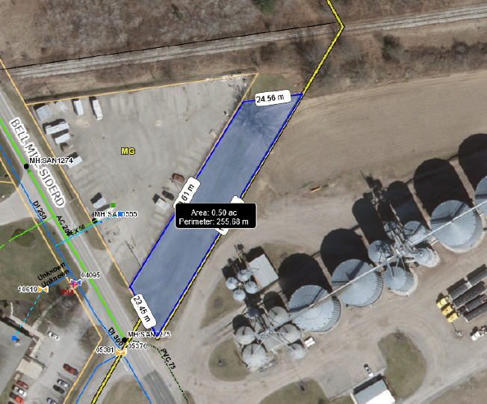

Additional information can be obtained by contacting:

Cephas Panschow, Development Commissioner
Town of Tillsonburg, Economic Development & Marketing
519.688.3009, x4007
cpanschow@tillsonburg.ca

The deadline for registering interest in purchasing the property or any concerns with respect to the proposed sale of this property has been extended to 4:00 p.m. on Wednesday, October 26, 2022.

Personal information collected and recorded at the public meeting or submitted in writing on this subject is collected under the authority of the Municipal Act, 2001, as amended, and will be used by members of Council and Town staff in their consideration of the application. The written submissions including names and contact information and the report of the public meeting will be made available to the public.
Questions about this collection should be referred to the Clerk at 519-688-3009.

